VOTING CLOSES ON SUNDAY, APRIL 11 AT 5PM

GRAND MARSHAL VOTING 2021
- FEMALE-IDENTIFYING NOMINEES
- Please select one candidate to serve as Female-Identifying Grand Marshal.*
  - MELANIE TOARMINA PANG
  - ALI LOZANO
  - ISABEL LONGORIA
  - KYMBERLIE MCGUIRE
- MALE-IDENTIFYING NOMINEES
- Please select one candidate to serve as Male-Identifying Grand Marshal.*
  - JOVON TYLER
  - C PATRICK MCILVAIN
  - JACQUES BOURGEOIS
- GENDER NON-BINARY NOMINEES
- Please select one candidate to serve as Gender Non-Binary Grand Marshal.*
  - KEVIN NGUYEN
  - MICHAEL STEWART
  - CHIP WARE
- ALLY NOMINEES
- Please select one candidate to serve as Ally Grand Marshal.*
  - ABBIE KAMIN
  - CHRIS HOLLINS
- YOUR INFORMATION

FEMALE-IDENTIFYING GRAND MARSHAL NOMINEES

MELANIE PANG
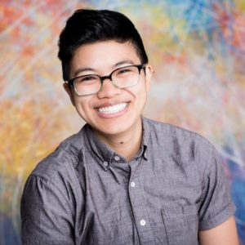(She/Her) Melanie Pang is a social worker, policy advocate, and community organizer. Currently, she serves as Director of Advocacy with the Houston Food Bank, working to create systemic change in the long term while alleviating suffering today; during the COVID-19 pandemic alone, she and her colleagues have helped distribute more than 234 million pounds of food to the Southeast Texas region. Prior to her food policy and advocacy work, she served as Manager of Emergency Disaster Services at the Salvation Army of Greater Houston and was a liaison in the City of Houston’s Emergency Operations Center throughout Hurricane Harvey relief efforts.
With a decade of experience in LGBTQ rights advocacy, she was appointed to serve as a founding co-chair of Mayor Turner’s LGBTQ Advisory Board, the first of its kind in the City of Houston. Throughout her career, Melanie has served in a variety of communities and capacities, aiming to further equity and lived equality – from advocacy efforts to reduce and prevent childhood obesity in food deserts to serving as a case manager to refugee youth and children in foster care, as well as many LGBTQ+ young adults experiencing homelessness.
She is a proud alumnus of the University of Houston, where she received her bachelor’s degree in journalism, was a scholarship recipient from the Houston Lesbian & Gay Community Center, and was one of the first two students to minor in LGBT studies at the university. While an undergraduate, she was president of GLOBAL, the university’s LGBTQ student group, for two terms and fought alongside students, faculty, and staff to expand its nondiscrimination clause to include sexual orientation, gender identity, and gender expression. She would later go on to be an active advocate for the Houston Equal Rights Ordinance (HERO) at city council and fight anti-LGBTQ bills at the state capitol.
Melanie holds a master’s degree from the University of Houston Graduate College of Social Work and was invited back to the university as an adjunct professor to teach Intro to LGBT Studies at the undergraduate level, as well as Organizational Behavior and Change at the graduate level. Melanie was named Social Worker of the Year in 2015 by the National Association of Social Workers Houston and received the President’s Award for Distinguished Community Leadership from the Houston GLBT Political Caucus in 2016. In 2018, she was presented the Humanitarian Award by the college of social work student association.
Melanie loves and is grateful to be loved by her wife, Kendall, and rescue dogs, Pepé and Honey.

ALESANDRA (ALI) LOZANO, MSW
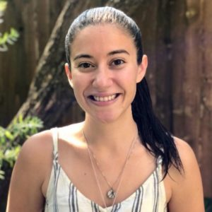(She / Her)Alesandra (Ali) Lozano is a proud political social worker and Houstonian who has been advocating for LGBTQ+ liberation since her own coming out in 2009. Currently, Ali works as the Outreach Manager at the Texas Civil Rights Project (TCRP) where she co-chairs the organization’s legislative advocacy efforts and helps lead campaign strategies for all three of the organization’s programs (Voting Rights, Criminal Injustice, and Racial/Economic Justice) ensuring that TCRP’s legal victories are felt outside of the courtroom. In Ali’s capacity at TCRP she also serves on the Steering Committee for the Houston in Action coalition – the collective power of people and organizations throughout the Greater Houston area coming together to promote community leadership and break down systemic barriers to civic participation. She has previously worked as the Political Manager for the LGBTQ Victory Fund and as the Houston Outreach Coordinator for the Texas Freedom Network. Outside of work hours, Ali has served on the Board for the Houston GLBT Political Caucus (2016-2017) where she was Membership Chair and as a Victory Campaign Board member at the LGBTQ Victory Fund helping to elect openly LGBTQ candidates at all levels of government – including several of our own out LGBTQ Houston lawmakers and officials. Ali has been named a Rising Star by the League of Women Voters of Houston (2016), a Top LGBTQ Woman Leader by OutSmart Magazine (2016), and an Inspiring Activist by the University of Houston Graduate College of Social Work (2019). She is the co-parent to two cats: Tito and Baldwin (named after Tammy Baldwin, America’s first openly lesbian United States Senator).

ISABEL LONGORIA
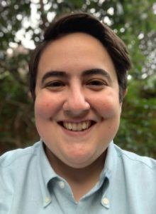(She / Her) Born of Mexican and French immigrant parents, Isabel is a proud policy wonk and native Houstonian. Some of her first childhood memories include catching beads at the PRIDE parades in Montrose and visiting Chances with her college friends later in life. Since then she has pursued a career in public service, often times as the only queer hispanic woman in the room. She has previously worked for AARP, State Senator Sylvia R. Garcia and State Rep. Jessica Farrar, and other Democratic organizations focusing on Latino/a and LGBT community organizing, affordable housing, and civic engagement. Isabel has also served on the City of Houston’s Planning Commission, the Mayor’s LGBTQ Advisory Board, the New Leaders’ Council Board, and the Board of the League of Women Voters. During her run for Houston City Council in 2019 she was endorsed by the Houston GLBT Caucus, Houston Stonewall Young Dems, and the Victory Fund. She has used these positions to elevate queer and Hispanic voices by never backing down from a fight, especially if it means a better life for someone else.
Following her innovative leadership during the November 2020 Presidential Elections, Isabel was appointed as Harris County’s first ever Elections Administrator. Thereby making her the first out, queer appointed official in Harris County history and one of the few Hispanic members as well. She is excited to build election and voter registration programs that supports LGBTQIA+ individuals in feeling safe and ready to participate in democracy.
In her spare time she loves to garden, wood work, obsess over her black cat (Atticus), and support local Houston businesses.

KYMBERLIE MCGUIRE
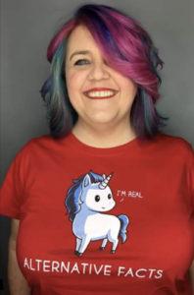A rainbow-hair-colored-lifelong feminist and outspoken advocate for our LGBTQIA+ rights, McGuire has been at the forefront as an ally and queer member of the Houston LGBTQ community since 2009 when she co-founded the nonprofit organization Houston Gaymers with Jacques Bourgeois, who she also served as co-Vice President with and spearheaded unique efforts to tackle intersectionality and connect our community through gaming.
In 2015 with marriage equality looming in the courts, McGuire and a friend took it upon themselves to launch PopVows where they organized free weddings for more than 19 LGBTQIA+ couples in Houston to finally fulfill their long awaited dream of marriage.
McGuire continues to fight for LGBTQIA+ rights to this day speaking on panels at conventions like Comic-Con and Pax South. McGuire her whole life has identified as straight but In 2018 courageously came out to her partner David, friends, and family as queer. McGuire currently serves as a board member of CASN (Clinic Access Support Network) and hopes to join Mayor Turner’s LGBTQ Advisory Board.

MALE-IDENTIFYING GRAND MARSHAL NOMINEES

JOVON ALFON B. "LUJACK" TYLER
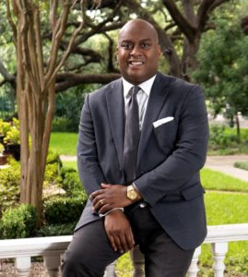(He / Him) A native Houstonian, Jovon Alfon B. “LuJack” Tyler was born at St. Joseph’s Hospital on June 22, the year of our country’s bicentennial. He grew up and went to church in Kashmere Gardens, and was humbly raised by his hardworking grandparents, Clara and Willie. At fifteen, he came out and ran away from home to Montrose where he would live on the streets for nearly two years.
An active community advocate from the beginning, Jovon became a member of ACT UP and Queer Nation Houston. His involvement with these groups lead him to be invited to join the Houston GLBT Political Caucus for which, at eighteen years old, he became the youngest person ever elected to serve on the Board. Dynamic, vigorous, and eager to achieve equality for all, Jovon won the group’s prestigious Newcomer of the Year Award.
Jovon would go on to create The Caucus’s Power Brunch, which was a catalyst in forging a relationship between the LGBTQIA+ community and City Hall; a relationship we all still enjoy today.
Jovon would later serve four years on the Board of The Caucus — including 2 years as Vice Board Chair — while also becoming one of the country’s first members of AmeriCorps. In 1998, he was selected to represent the United States abroad in Brazil for YMCA International. While in Brazil, he served at-risk youth in the most impoverished parts of the city of Belo Horizonte. Upon returning home, he worked as a staff intern for the first openly LGBTQ city council member elected in the City of Houston, future Mayor (and adoptive mother) Annise D. Parker.
For five consecutive summers, Jovon worked with AIDS-affected orphans in Lusaka, Zambia, and was instrumental in getting a school built that continues to educate vibrant, new generations of Zambians to this day.
Jovon was also selected to be a member of Leadership Houston, Class XXXIV.
Currently, Jovon is the Strategic Community Lead for UNITE, which is a Dignity Memorial associate resource, led by associates, with the support of the company to educate, advocate and raise awareness in the organization for LGBTQIA+ issues, partnerships and equity for all. Jovon is the Chairman of the Board of Directors for Iconoclast, a non-profit that teaches creative writing and art to at-risk youth and annually publishes an anthology of their work, and also serves on the Board of Advisors of Holocaust Museum Houston. Mayor Sylvester Turner has twice appointed him to serve on the Montrose TIRZ Board, and, after nearly two decades away, Jovon has returned to The Caucus to serve as President — a role he has been elected to twice.
Jovon has been married to his wonderful husband, Justin, for 4 years. They recently expanded their family this past Fall when they adopted their son, Malachi. He is also the Godfather of Geneva, Ford and Levi.

C PATRICK MCILVAIN
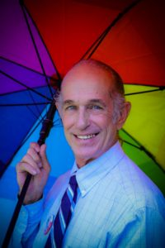(He / Him) Patrick was for many years active with the Houston International Festival, still volunteers for The City of Houston’s Department of Special Events with such events as the annual Christmas Tree lighting in front of City, portraying an elf, the Fourth of July Fireworks display, the Art Car Parade and more. Many know him from his work as an election clerk during early election periods and as an election day judge but the project closes to his heart is The Walk for Mental Health Awareness which he founded and serves as Director, and that will be celebrating it’s tenth year in 2020. Taking his personal experience as a person challenged with neuropsychiatric illness, he became a fierce advocate to help others with the goal to end the stigma which prevents people from seeking help and treatment, and to encourage a positive public dialogue.
The Walk helps non-profits that provide mental health services to raise funds. This cause is important within the LGBTQA community where so many of us are affected by discrimination and oppression that can lead to depression and anxiety, as well as addiction issues that are prevalent in the community. These are but the tip of the iceberg of Patrick’s accomplishments and contributions. He was recognized by the Coalition of Behavioral Health Services with their 2019 Courage Award.

JACQUES BOURGEOIS
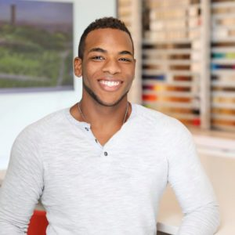(He / Him) One individual was an early voice in our community, taking this organization, Pride Houston, to task on its ambivalence towards the deeply-meaningful celebration of Juneteenth for the black queer community back in November of 2014. He garnered significant support from our community to push the organizers to change the date of the Pride celebration to avoid conflict with Juneteenth, which would have made black queer people choose between celebrating their queerdom or Blackness. He has been a steady pillar in our community as a founder of Houston Gaymers, a Bunnies on the Bayou board member, a leader on Mayor Turner’s LGBTQ advisory board, and a plethora of other events and organizations aimed at uplifting the community, including being one of the tireless activists at the forefront of the Houston Equal Rights Ordinance (HERO). He was instrumental in planning and executing Mayor Turner’s inaugural #HoumanityAwards, which recognized leaders and changemakers in the LGBTQIA+ community whose praises often go unsung. He is already ready to work on behalf of those who need and deserve help the most. Jacques is someone who exemplifies what it means to be a passionate servant leader, friend, and role model for our youth in the LGBTQIA+ community.
Jacques is currently working on the ground work for the next version of the (Monica Roberts) Equal Rights Ordinance, leading the committee on the Mayors LGBTQ advisory board with the aim of intersectional Houstonian buy in and the express goal to make it not just an ordinance for the City of Houston but also clear the path for it to become Texas state law as well.
Post pandemic, he plans to get back to working on launching Out Professionals – Houston and continue to connect and strengthen our Houston LGBTQIA+ community by helping them to find opportunities in our post pandemic world & still show up as their authentic selves.

GENDER NON-BINARY / NON-CONFORMING GRAND MARSHAL NOMINEES

KEVIN NGUYEN
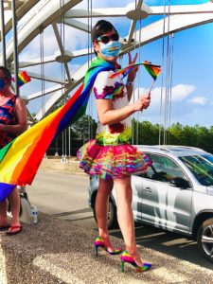(They/ Them/ Theirs) Kevin is a first-generation, Texas-born, Vietnamese American. Originally from the Houston area, but they have moved quite a bit throughout childhood due to family and educational/personal endeavors. Though they have lived in other parts of this country, Houston will always be their home.
Kevin is pursuing a degree in Psychology as a student at the University of Houston, because with the emphasis and generally acknowledged need for improved mental health/wellness in our society Kevin believes it is important to be immersed in this area of the social sciences and to try to connect with others in the larger community.
Within their work and lifestyle, Kevin wants to produce a certain sense of inclusivity, curiosity, and mutual respect for those they interact with. Having immigrant parents and being an active volunteer member in organizations like Bunnies on the Bayou, Pride Houston, and the Mayor’s LGBT Advisory Board has been an eye opener of the different aspects and complexity of being LGBTQIA+, a person of color, and a voting member of this country. Learning about nuances within our communities and identity development is imperative to growth, maturity, and support. Seeing first-hand of all the experiences and diversity this metropolitan city provides have been enlightening and worthwhile towards fully being engrossed in people’s story/upbringing/lifestyle and getting to know who they truly are and Kevin’s own journey.
They have their biological family and logicial or “chosen” family within their identity as an LGBTQIA+ individual because there is a challenging area of dissonance and disagreement in some of the aspects of love, compassion, and one’s role in society. Nonetheless, Kevin still appreciates what their ethnic background and racial identity have also contributed to a significant part in learning about group affiliation and social belonging. Recognizing and applying that multiple identities interplay within the spectrum development of people’s understanding of themselves will lead to more inclusion and acceptance without always complying to societal expectations, gender norms, and heteronormativity.

MICHAEL "STOO" STEWART
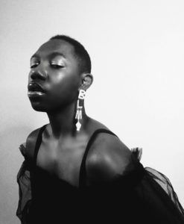(They/ Them/ Theirs) Known by their artist name, STOO, Michael has challenged gender norms since 2016 and has opened doors, even at their relatively young age, for the rest of the non-binary community members through their music, performance art pieces, and social media presence.
They have co-founded (along with Space Kidettes) a queer artist showcase, Abundantly Queer, at Pearl Bar to celebrate and amplify local LGBTQIA+ musicians, comedians, DJs and drag entertainers. Outside of being creative, Michael uses their social media platform as a space for self-empowerment and reflection, discussing issues regarding Black and LGBTQIA+ people, and mostly importantly spreading the true essence of love.
It’s time to challenge what leadership looks like and how it bleeds into different fields and Michael does this without even attempting by using their fabulous light and unapologetic voice.
To follow Michael:
instagram.com/stooizm

CHIP WARE
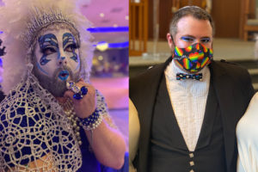(They/Them) Chip has been an outspoken activist, fundraiser, and social organizer in the LGBTQIA+ community for over 25 years. Early in their journey, Chip focused their passion on organizations like RAINN, helping build inclusive policies to make the network a safe space for trans and other non-conforming individuals. They have helped found several non-profit organizations, including the Bayou City Pups and the Space City Sisters, the Houston chapter of the Sisters of Perpetual Indulgence. You can often find Chip advocating for better and more accessible sexual awareness education, specifically around HIV/AIDS. Chip also organizes within their other communities, including the Jewish community and the Renaissance Faire circuit. They serve as an Ambassador for the Texas Renaissance Festival, where they provide tours for newcomers as part of a fundraising program for accessibility and support organizations such as RESCU and ASL Faire’s TX. Married in June 2020, Chip and their husband, Tank, are the owners of The Montrose Forge, a local small business located in Montrose. As a member of the Space City Sisters, you may see Sister Kitty out and about stirring up trouble while handing out safer sex packets and trying to bring a smile to the community that has given them so much.
https://www.facebook.com/chippuprok
https://www.facebook.com/sister.kitty.licken

ALLY GRAND MARSHAL NOMINEES

ABBIE KAMIN
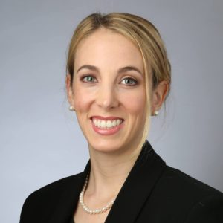As the Houston City Council Member representing District C, Abbie is a longtime, steadfast ally and supporter of the LGBTQ+ community. She embraces intersectionality and understands how social justice movements connect with each other to push equality forward.
She has never faltered in her dedication to fairness nor wavered in her support for full equality. In just her first year on Council, she has worked to ensure that COVID vaccine forms were gender and non-binary inclusive, advocated for the inclusion of LGBTQ+ in examining the diversity in Houston’s Arts acquisitions, nominated LGBTQ+ advocates and community leaders to City Boards and Commissions, worked with The Montrose Center and Legacy Community Health, and supported efforts of the Greater Houston LGBT Chamber to make the City of Houston an even more inclusive place.
She has advocated for our community openly and without apology, is a proud Ally-member of the GLBT Caucus, and made LGBTQ+ issues her focus during her first year as a Council Member.
Prior to serving on Council, as a civil rights attorney, Abbie focused her efforts on voting right, voter access, and equal representation, including drawing attention to the discriminatory harms of Texas’ voter-photo ID law in the Trans community, and advocating to ensure everyone is counted in the redistricting process, including those currently in prison.
As the Associate Regional Director of the Anti-Defamation League’s Southwest Regional Office, she oversaw the region’s civil rights programming, responses to incidents of hate throughout half the state, and fostering community partnerships. This included working with partners at Lambda Legal, Transform Houston, and other advocacy organizations. As the Committee Director and Clerk for the Texas House Human Services Committee, she fought for solutions to Texas’ foster care crisis, including combatting a bill that permits foster care providers to discriminate against LGBTQ partners and their families.
In short, Council Member Kamin is a hard worker, a forward-looking leader, an intersectional grassroots organizer, and a steadfast ally and advocate for our community.

CHRIS HOLLINS
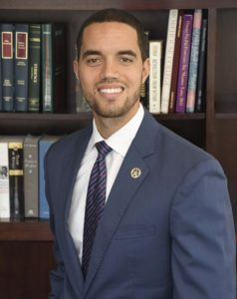Chris Hollins, an attorney and fourth-generation Houstonian, is the former County Clerk of Harris County, Texas. In private practice, he is the Principal Attorney at Hollins Law Group PLLC.
Chris has been a longtime supporter of the LGBTQ+ community. Most recently, as Harris County’s Chief Election Officer, he ensured that members of the LGBTQ+ community were always at the table to ensure that policies were in place to protect the right to vote for all, including mandated training for election officials to ensure that trans and non-binary persons could cast their votes. Chris also established the first-ever voting center located at a gay bar. The Houston GLBT Political Caucus presented Chris with the Kristen Capps Social Conscience Award based on his phenomenal, inclusive work during the 2020 election season.
Chris developed a commitment to public service through the selfless example of his parents and their devotion for improving the lives of others. His father, George, served for 34 years in the Houston Police Department, and his mother, Christie, managed a career as an administrative assistant while raising Chris, his two sisters, and more than 20 young foster children.
Before transitioning into private practice, Chris developed strong strategic skills by working at some of the world’s most distinguished professional service firms. As a management consultant with McKinsey & Company, he flourished in applying analytics and organizational best practices to transform public safety, defense, and security agencies. He also served in the White House Office of Presidential Personnel.
Chris holds a Bachelor of Arts in Political Science with Phi Beta Kappa honors from Morehouse College. Chris also completed a joint program with Yale Law School and Harvard Business School, earning both his Juris Doctor and Master of Business Administration degrees. Today, Chris is admitted to the State Bar of Texas and Federal Courts for the Southern District of Texas. He is an alum of New Leaders Council. Chris has served on numerous nonprofit boards and has been a Big Brother for over a decade.
Since the conclusion of his term as County Clerk, Chris has continued to serve as an advocate for voting rights, democracy, and good government. He believes that our state and our nation must—in addition to addressing countless issues to improve the human condition—protect the basic elements of democracy for all citizens so that “government of the people, by the people, for the people, shall not perish from the earth.”
Chris resides in Houston’s Third Ward with his wife Morgan, their daughter Vivian, and their son George. The Hollins family attends Wheeler Avenue Baptist Church.

